***Planning and preparation to include:***

* ***1*** ***Identify target market***

**The target audience of the site is people who are interested in quality coffee and are looking for gifts for themselves or their loved ones. Below are several groups of potential customers:**

**-Love coffee and want to try different varieties and flavors of coffee;**

**- Are interested in high-quality products and are willing to pay extra money for them;**

**- Looking for gifts for friends, colleagues, relatives who also love coffee and appreciate the quality of products;**

**-Want to buy a coffee set for themselves or as a gift online, from the comfort of home;**

**- Appreciate the environmental friendliness and naturalness of products;**

* ***2*** ***List site objectives***

**-Sale of coffee sets: one of the goals of the site is to use the site to attract new customers, inform them about products and the possibility of purchasing them online.**

**-Increase brand awareness: the purpose of the site is to increase brand awareness and increase credibility among those present. for company presentations, helping to connect with the audience and attract new ones.**

**- Information provided: the purpose of the site is information about the company, products and services for customers.**

***3.Site map and logical navigation solution***

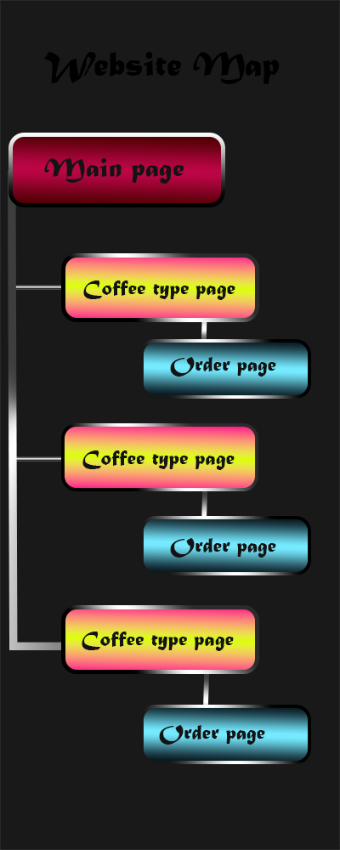

**4.** ***Sketching of initial design concepts***

***I came up with the design of my site using Photoshop and looked for Pinterest references that inspired me. I had several similar website design ideas, and on Pinterest, I selected pictures that could be used as backgrounds. This process was very creative and engaging, and I paid special attention to every detail to create a unique and attractive design for my site.***

***References:***

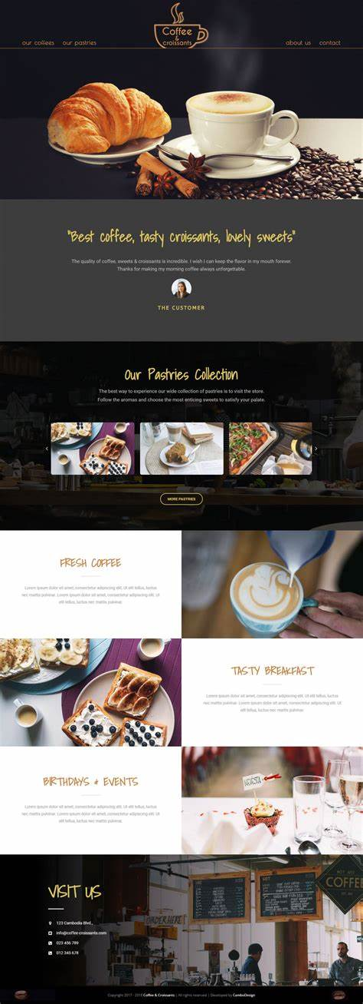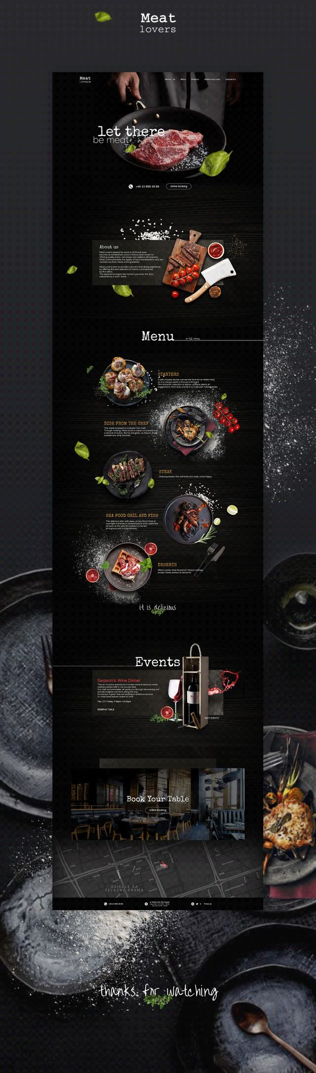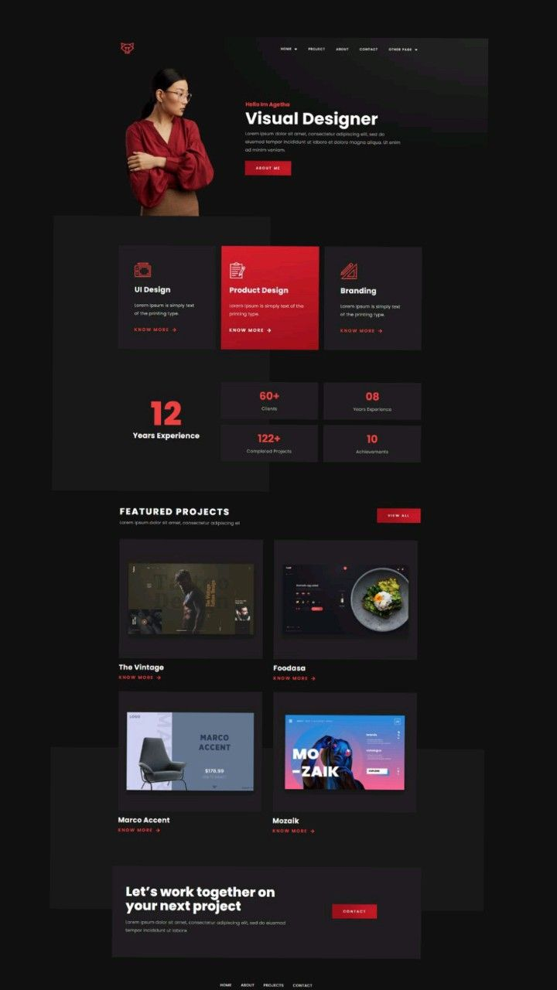

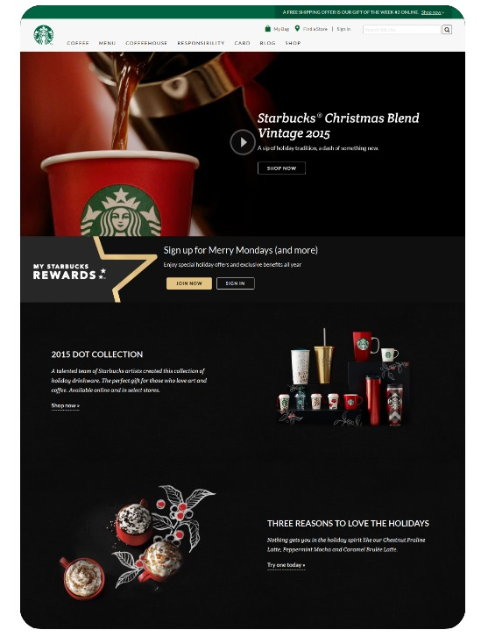

**Pictures for website:**

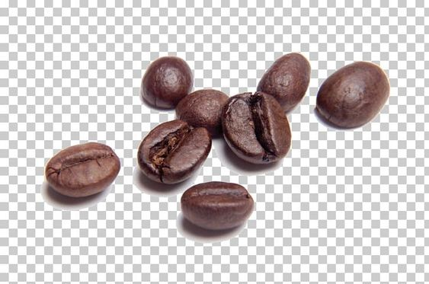

**My website ideas:**

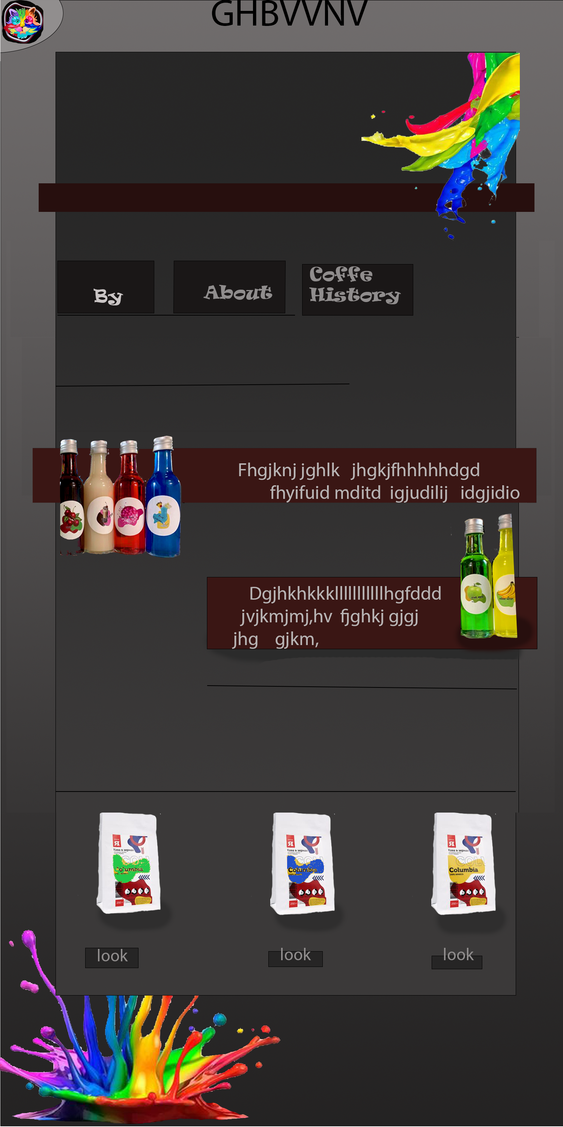

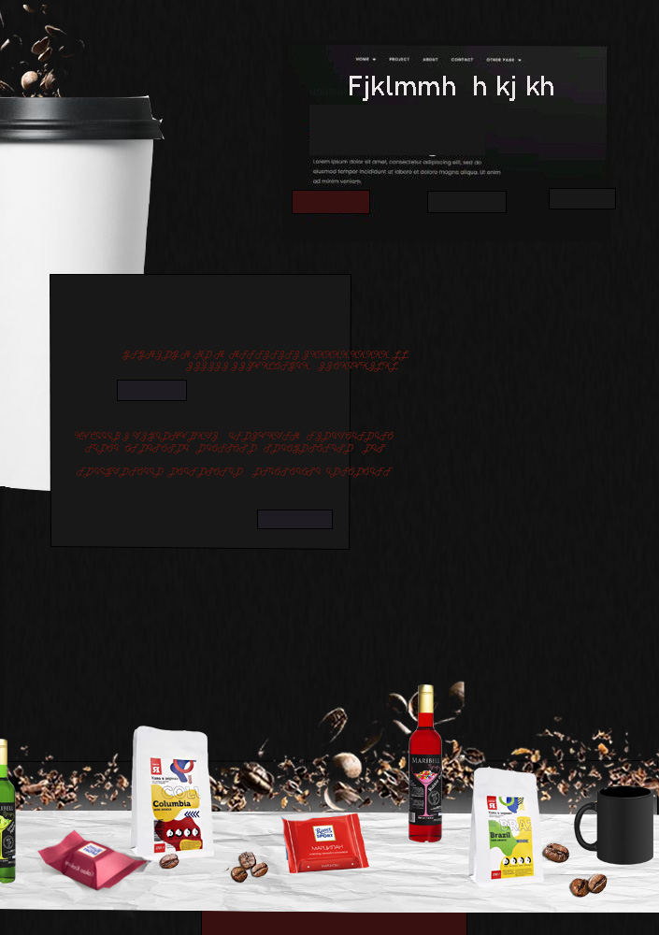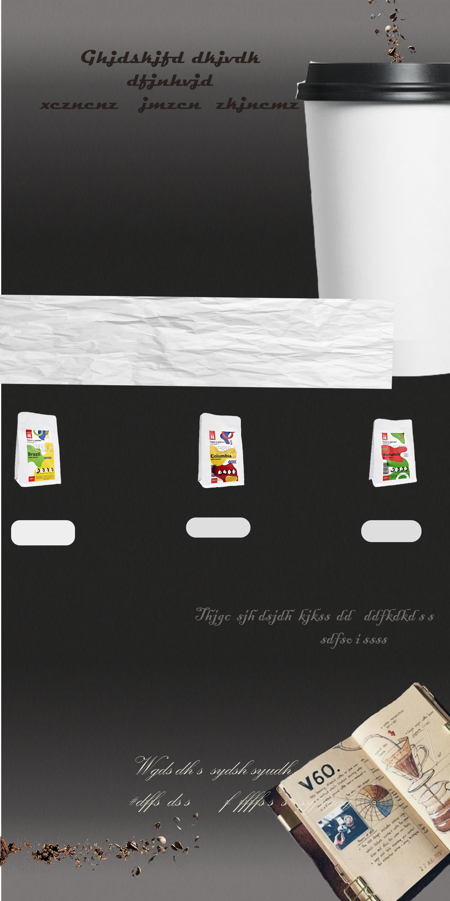

***5.Identify tools for creation and maintenance of website including***

* + ***HTML and CSS***
  + ***Graphics***
  + ***Site uploading***

**1.HTML and CSS are markup and styling languages for web pages. HTML is responsible for the structure and content of the page, while CSS is responsible for its appearance and style. To write code in these languages, you can use various integrated development environments (IDEs) such as Visual Studio Code, Sublime Text, or Atom.**

**2.Graphics - Graphic editors are used to create website graphic elements such as logos, images, backgrounds and others. Some of the most common graphics creation tools include Adobe Photoshop, Sketch, GIMP, and Canva.**

**3.Site Upload - Various tools can be used to upload a site to the server and manage it. For example, FTP clients like FileZilla or Cyberduck allow you to upload and manage files to a server, while hosting control panels like cPanel or Plesk provide a user-friendly interface for managing a site on a server.**

**6**

**7** **Development of website to include:**

* Use of text

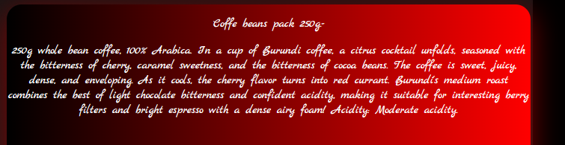

* Use of images

Image link

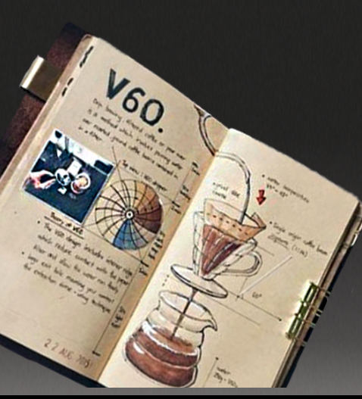

Images for 1 page:

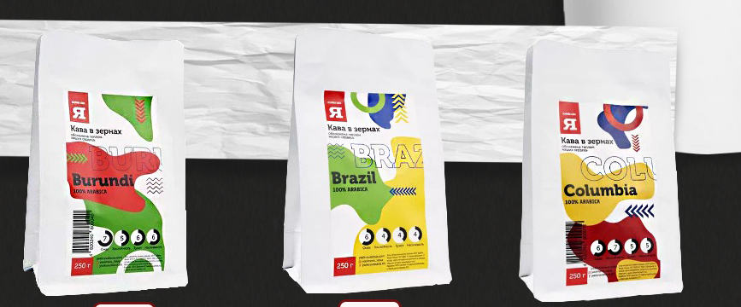

Images for checkout page:

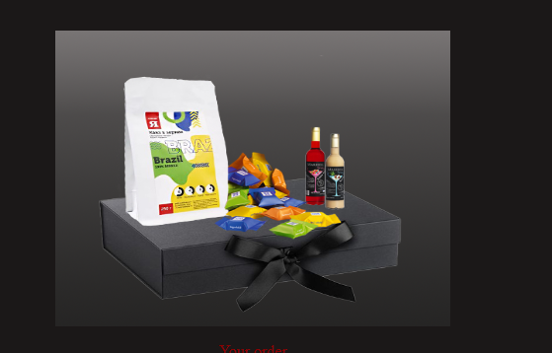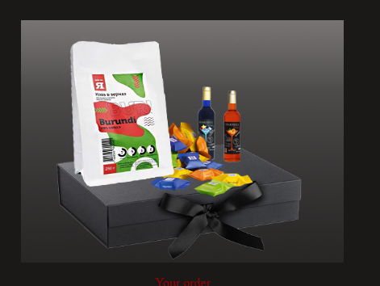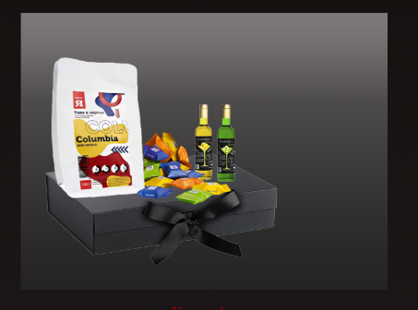

Images for coffee recipe book page:

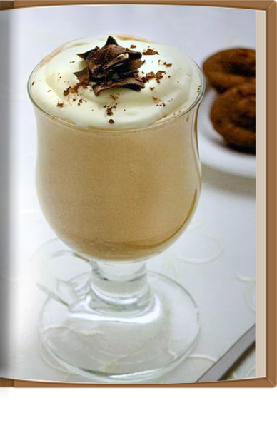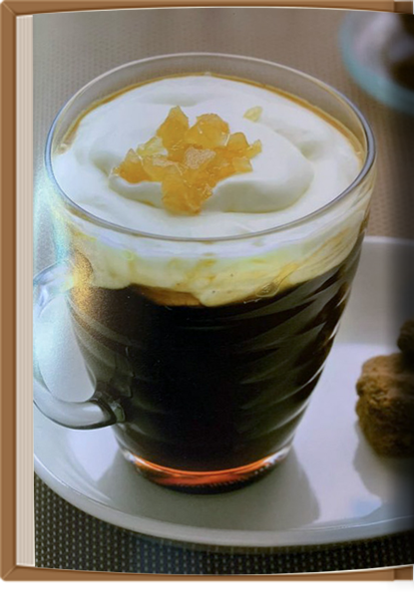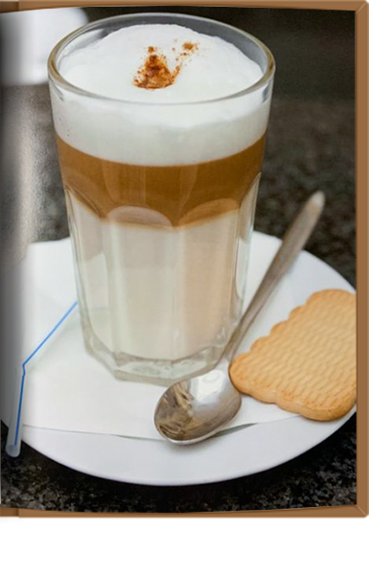

Images for link (made in photoshop):



Page background images:



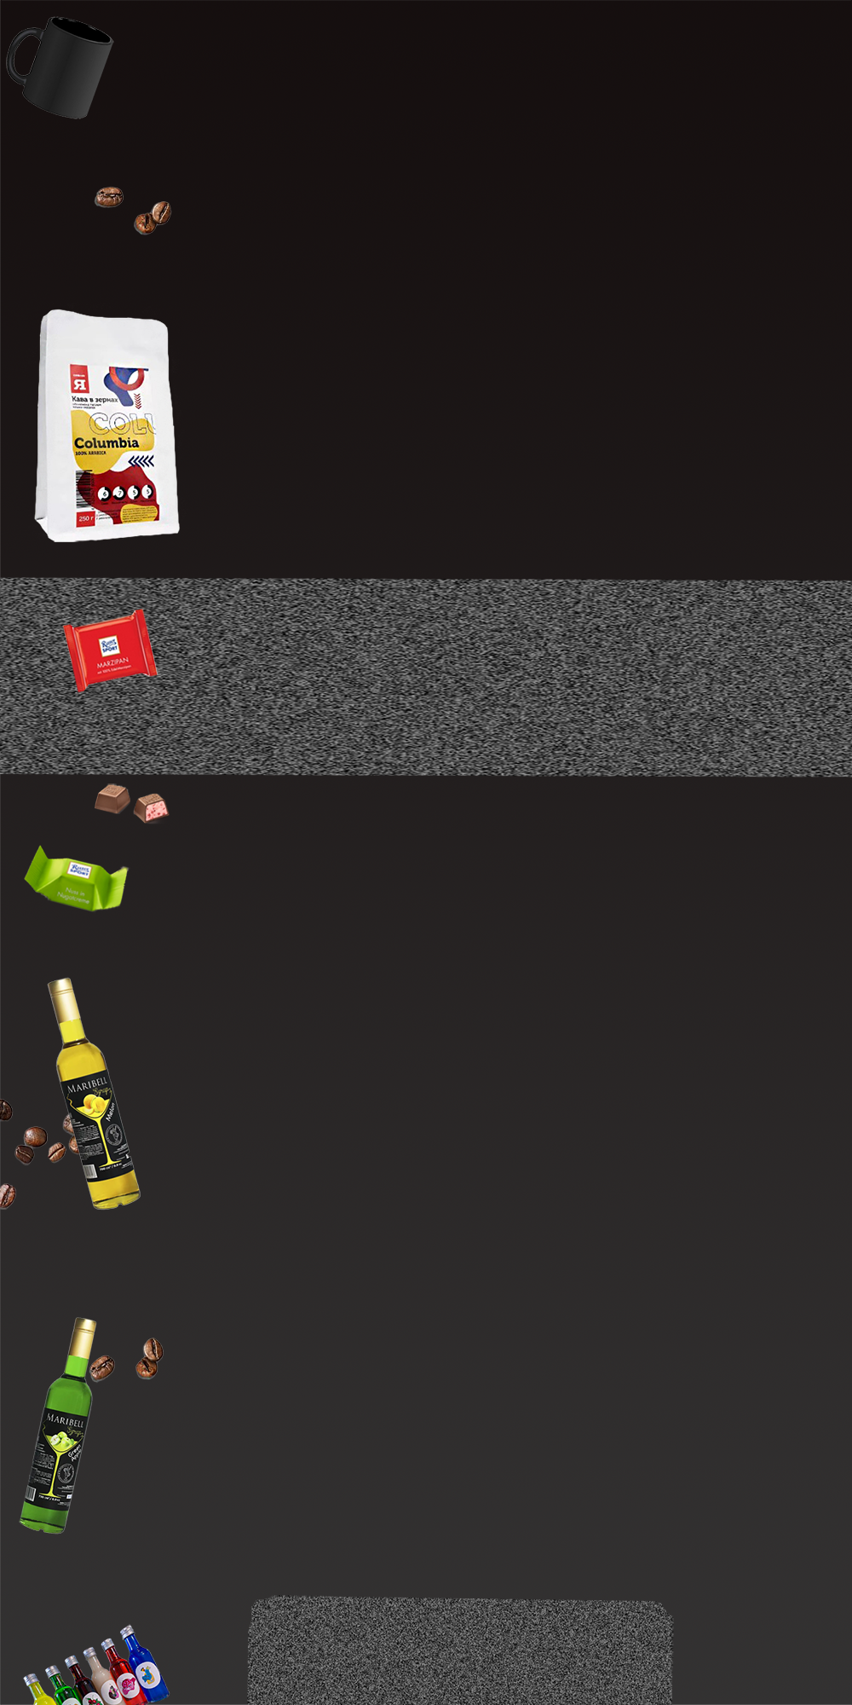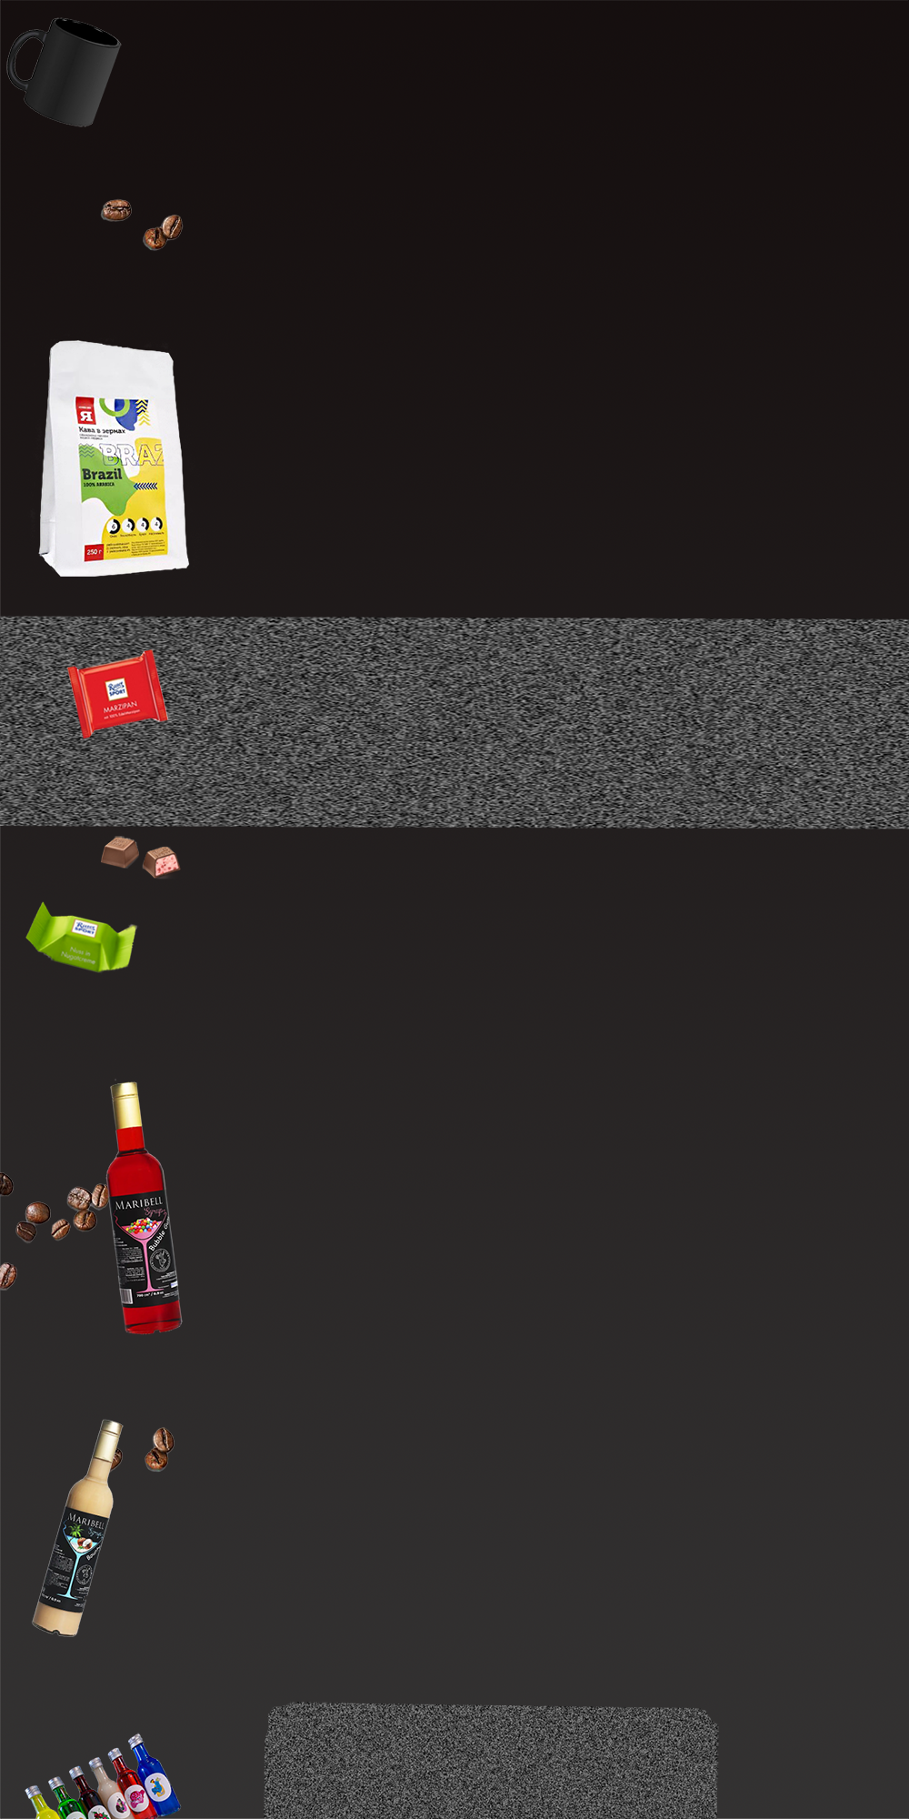

* Correct employment of HTML and CSS to include:
  + Correct HTML page structure
  + Use of current HTML tags

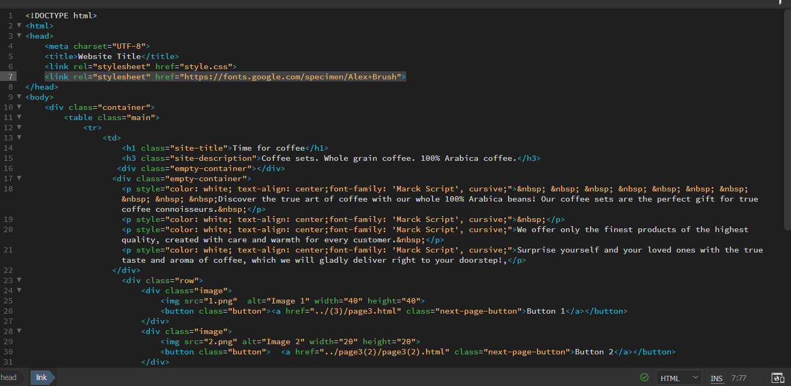

**<head>:** This is the tag that contains information about the page, such as the title, meta tags, and links to external files.

**<meta charset="UTF-8">:** This is a meta tag that sets the character encoding for the page.

**<title>:** This is the tag that sets the title of the document that will be displayed in the browser tab.

**<link>:** This is the tag used to link CSS files

**<body>:** This is the tag that contains the main content of the page, including text, images, tables, lists, and other elements.

**<div>:** This is the tag that is used to create blocks of content and arrange elements on the page.

**<table>:** This is the tag that is used to create tables on the page.

**<tr>:** This is a tag that points to a new row in a table.

**<td>:** This is a tag that points to a cell in a table.

**<h1>:** This is the tag that is used to create different levels of headings.

**<p>:** This is the tag that is used to create paragraphs.

**<img>:** This is the tag that is used to insert images into the page.

**<button>:** This is the tag that creates the button on the page.

**<a>:** This is the tag that creates a hyperlink on the page.

* Correct use of CSS to execute planned design of website to include:
  + Class and id as selectors
  + Font and text properties
  + Background properties
  + Positioning; absolute, relative, static, fixed, float
  + Borders
  + Padding and margins

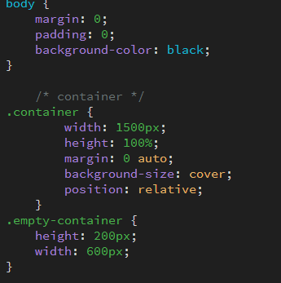

**body** - defines the main content of the page, such as text, images, tables, and other elements. color page -black

**.container** -is a class selector that applies to HTML elements that have a class="container" attribute

***width:*** *1500px; - this sets the width of the element to 1500 pixels.*

***height****: 100%; - this sets the height of the element*

***margin:*** *0 auto; - this sets the top and bottom margins of the element to 0, while the left and right margins are automatically centered.*

***background-size****: cover; - this sets the size of the background image that is set on the element so that it takes up the entire area of the element and is not distorted.*

***position:*** *relative; - this specifies the positioning of the element relative to its original location and the rest of the elements on the page*

**.empty-container** - container for empty space. defines a block with empty content 200px high and 600px wide.

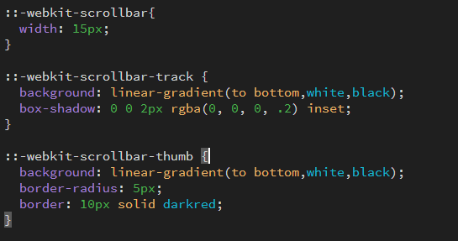

**::-webkit-scrollbar** - defines the style of the scrollbar on the page.

***width:*** *15px; - sets the width to 15 pixels.*

**::-webkit-scrollbar-track** - defines the style of the scrollbar background on the page.

***background:*** *linear-gradient(to bottom, white, black); - sets a gradient background for the scroll track,*

***box-shadow:*** *0 0 2px rgba(0, 0, 0, .2) inset; - adds a shadow inside the scrollbar track to create a depth effect.*

**::-webkit-scrollbar-thumb** - defines the style of the scrollbar slider on the page.

***background:*** *linear-gradient(to bottom, white, black); - sets a gradient background for the scrollbar element, going from white at the top to black at the bottom.*

***border-radius:*** *5px - sets the rounding of corners*

***border:*** *10px solid darkred; - sets the width and style of the border of the scrollbar element.*

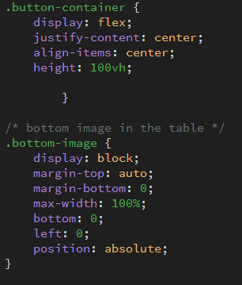

**.button-container** - defines a container for buttons.

**.bottom-image** - defines the image at the bottom of the page.

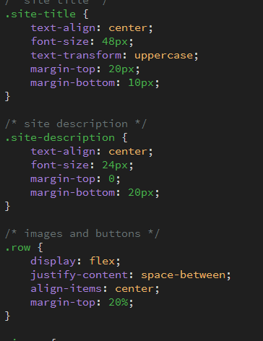

**.site-title** - defines the title of the site.

**.site**-description - defines the site description.

**.row** - defines a row that can contain multiple columns.

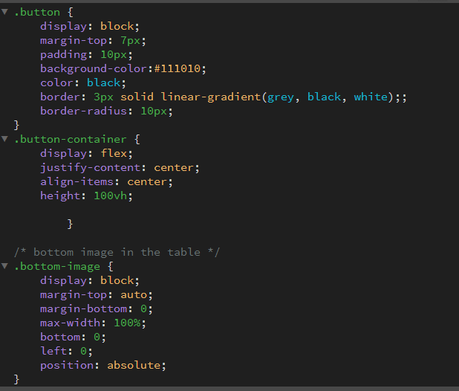

**.button-container** - defines a container for buttons.

**.bottom-image** - defines the image at the bottom of the page.

**.bottom-text** - defines the text at the bottom of the page.

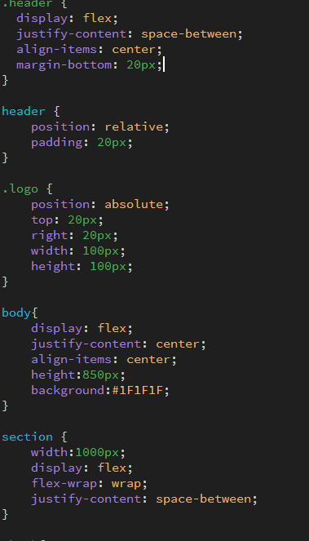

**header:** This tag points to the "header" element on the page.

**.logo:** This tag points to an element with the class "logo" on the page. This element contains the site's logo, which will be displayed in the upper right corner.

**body:** This tag refers to the "body" element on the page. It defines the main content of the page, including the background and alignment.

**section:** This tag points to a "section" element on the page. It sets the parameters for the section in which blocks with books will be located.

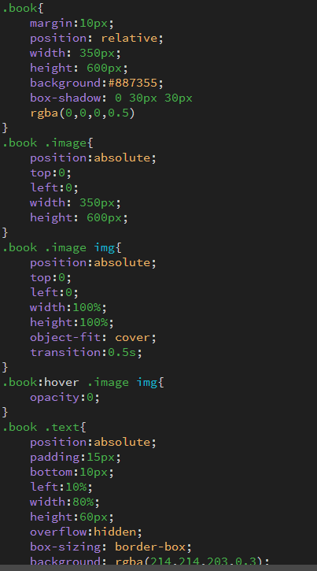

**.book:** This tag points to an element with the class "book" on the page. This element represents the book card that will be displayed on the page.

**.book .image:** This tag points to an element with class "image" inside an element with class "book". This element contains an image of a book.

**.book .image img:** This tag points to an "img" element within an element with the class "image". It defines parameters for the image, including its size and position.

**.book:hover .image img:** This tag specifies that hovering over an element with class "book" inside an element with class "image" will change the image settings.

**.book .text:** This tag points to an element with class "text" inside an element with class "book". This element contains a textual description of the book.

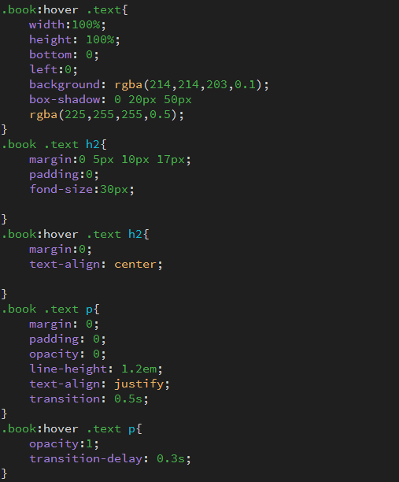

**.book:hover .text:** This tag specifies that hovering over an element with the class "book" will change the text options.

**.book .text h2:** This tag points to a heading inside an element with the class "text". It defines the options for the header.

**.book .text p:** This tag points to a paragraph within an element with the class "text".

Future planning to include

* Create maintenance guidelines to include the following
  + Updating text on a webpage
  + Creating a new webpage
  + Inserting an image
  + Creating a link
  + Uploading updated content to a website

In the future, the following improvements could be made to the website:

Adding links to the store's social media pages (Telegram, Instagram).

Adding a page for customer reviews.

Expanding the range of syrups and coffee flavors.

Adding a feature for customers to create their own syrup blends to suit their individual tastes.

Adding syrups with sugar substitutes for customers who cannot consume sugar.

Adding mini jars of honey for making honey lattes.

Adding a product page for creamed honey with various flavors for toast

Adding natural fruit pastilles.

Adding more interesting coffee recipes and a page for different brewing methods (coffee machine, geyser coffee maker, etc.).

Creating an attractive page on the history and origin of coffee beans.

Possibly creating a separate section of the website for teas.

**-Site uploaded to a web server or local server**

* + **Use of FTP**

**-Test website functionality**

I have thoroughly checked the functionality of the website and am confident that it is in good working order. all its functions, links and pages are working correctly and the website is user friendly and responsive. I have opened my website in different browsers such as Microsoft edge and google chrome all functions are correct and working.